Part Number: PT936-33130-XX

Kit Contents

|  |  |  |
| --- | --- | --- |
| Item # | Quantity Reqd. | Description |
| 1 | 1 | Front Driver Door Guard (Reference Pink Sticker) |
| 2 | 1 | Front Passenger Door Guard  (Reference Blue Sticker) |
| 3 | 1 | Rear Driver Door Guard (Reference Green Sticker) |
| 4 | 1 | Rear Passenger Door Guard (Reference Yellow Sticker) |
|  |  |  |

Hardware Bag Contents

|  |  |  |
| --- | --- | --- |
| Item # | Quantity Reqd. | Description |
| 1 | N/A |  |
|  |  |  |

Additional Items Required For Installation

|  |  |  |
| --- | --- | --- |
| Item # | Quantity Reqd. | Description |
| 1 | A/R | Simple Green All-Purpose Cleaner – Full Strength |
| 2 | A/R | Lint-free towel |
| 3 | A/R | Blue painter’s masking tape |
| 4 | 1 | Scissors |
|  |  |  |

Conflicts

|  |
| --- |
|  |

Recommended Tools

|  |  |
| --- | --- |
| Personal & Vehicle Protection | Notes |
| None |  |
| Special Tools | Notes |
| PPO Magnetic Template | IADS p/n =  ES513-D5-01 |
| Sealant Adjustment Tool | IADS p/n=  HIG11-D5-03 |
| DIO Paper Door Templates | See last page of these  instructions |
| Nylon Removal Tool(NRT) | SST p/n =  00002-06002-01 |
| Installation Tools | Notes |
| 12-oz. rubber mallet | IADS p/n =PRI10-D5-02  Vaughn, p/n = SF12 |
| Special Chemicals | Notes |
| Simple Green or VDC approved cleaner |  |

General Applicability

|  |
| --- |
| All |

Recommended Sequence of Application

|  |  |
| --- | --- |
| Item # | Accessory |
| 1 | Body Side Molding |
| 2 | Door Edge Guard |
|  |  |

\*Mandatory

Vehicle Service Parts (may be required for reassembly)

|  |  |  |
| --- | --- | --- |
| Item # | Quantity Reqd. | Description |
| 1 |  |  |
| 2 |  |  |
| 3 |  |  |
|  |  |  |

Legend

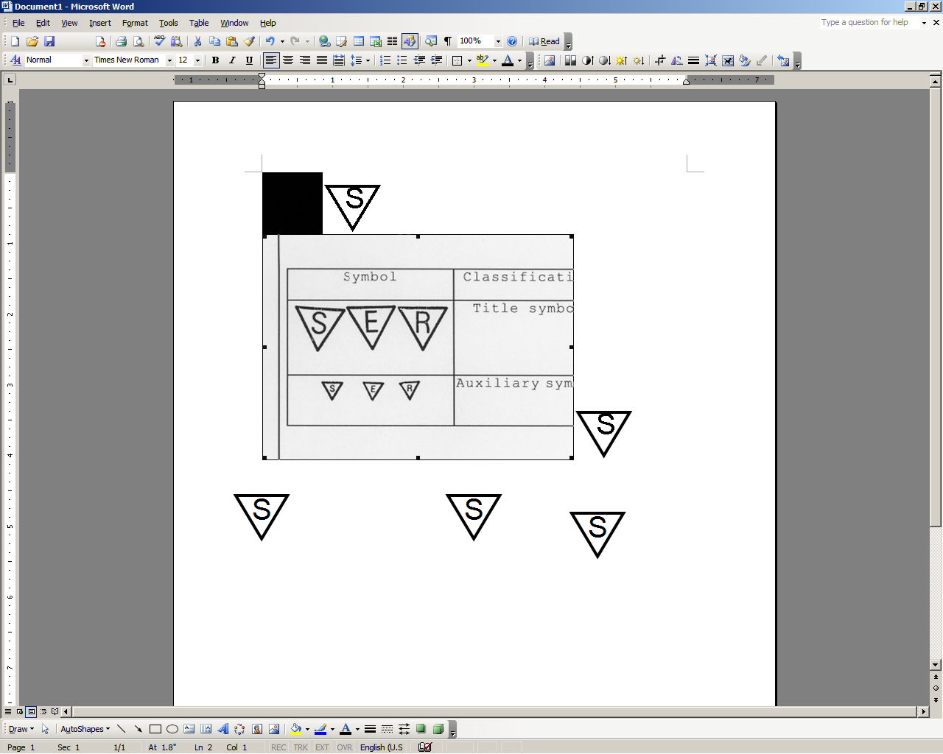

**STOP:** Damage to the vehicle may occur. Do not proceed until process has been complied with.

**OPERATOR SAFETY:** Use caution to avoid risk of injury.

**CAUTION:** A process that must be carefully observed in order to reduce the risk of damage to the accessory/vehicle and to ensure a quality installation.

**TOOLS & EQUIPMENT:** Used in Figures calls out the specific tools and equipment recommended for this process.

**REVISION MARK:** This mark highlights a change in installation with respect to previous issue.  
  
**SAFETY TORQUE:** This mark indicates that torque is related to safety.



Care must be taken when installing this accessory to ensure damage does not occur to the vehicle. The installation of this accessory should follow approved guidelines to ensure a quality installation.

These guidelines can be found in the "Accessory Installation Practices" document.

This document covers such items as:-

* Vehicle Protection (use of covers and blankets, cleaning chemicals, etc.).
* Safety (eye protection, rechecking torque procedure, etc.).
* Vehicle Disassembly/Reassembly (panel removal, part storage, etc.).
* Electrical Component Disassembly/Reassembly (battery disconnection, connector removal, etc.).

Please see your Lexus dealer for a copy of this document.

Rear Door Edge Guard (DEG).

* 1. Prepare the surface(s).

caution_2**NOTE:** It is *critical* to this installation that the vehicle’s door edges are *completely free of wax and oil residue* to permit the DEG to engage and grip the door’s edge. The key goal for preparation is to ensure complete removal of residue that can prevent the DEG from gripping. Please follow the steps in their entirety.

For PPO installations, refer to the Sealant Adjustment Tool notes on Page 11, if necessary.

* + 1. Fully open the rear driver side door.
    2. Using 2 (two) lint free cloths:
       - 1. Spray three to four pumps of Simple Green (or VDC approved cleaner) onto a lint free towel and pinch the wet towel between your thumb and forefinger while running along the length of the door edge to clean the inside and outside of the trailing edge of door. Make several passes to ensure the wax and oil has been removed (Fig. 1-1).

Fig. 1-1

Trailing Edge

* + - * 1. **caution_2**Using the second lint free cloth, thoroughly dry the area free of Simple Green (or VDC approved cleaner) previously applied. In some instances a rubber weather seal may be found – ensure to clean between the trailing edge and rubber seal (Fig. 1-2). Turn the cloth repeatedly to attain a dry surface.

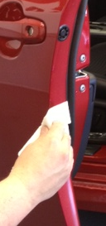 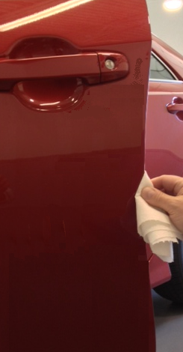

Fig. 1-2

**NOTE: To be cleaned correctly, resistance must be felt on the lint free towel and a “squeaky clean” sound must be heard during the drying process.**

* + 1. Repeat Step (2) if resistance is NOT felt and the “SQUEAKY CLEAN” sound is NOT heard. Keep repeating Step (2) until resistance is felt and a “squeaky clean” sound is heard.
  1. caution_2Install the Rear Door Edge Guard (DEG).

**NOTE:** If being installed at a Port, all references to “template” refer to a magnetic template. If being installed by a dealer or individual, all references are to the paper templates located on the last page of these instructions.

* + 1. caution_2If you will be using the paper templates, use scissors and carefully cut them out at this time.

**NOTE:** Magnetic templates are reversible for use on both sides of the vehicle. Ensure the magnetic template is clean prior to using.

* + 1. Select the rear door template and fit the notch around the door handle. Adjust it as needed to ensure it is aligned to the character line as noted on the template. If needed, tape it into place using painter’s masking tape (Fig 1-3).

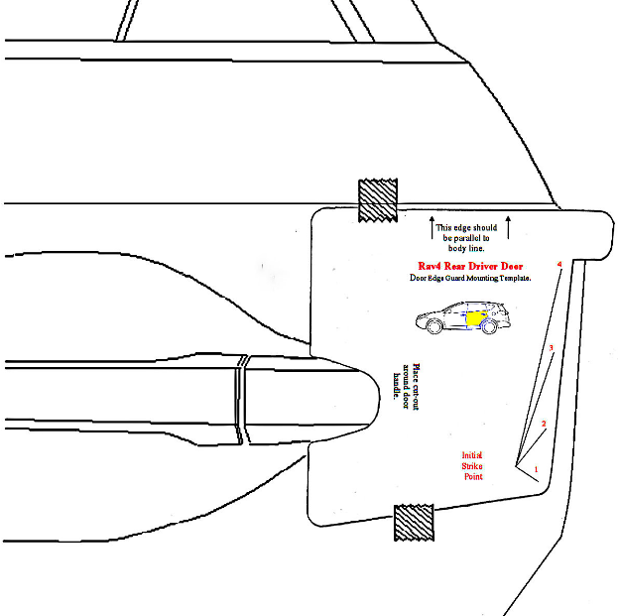

Align to Character Line

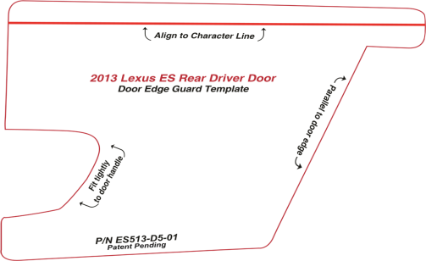

Align to Character Line

Fig. 1-3



* + 1. caution_2Align the top edge of the DEG (labeled Rear Driver with Green sticker), with the lower edge of the template alignment notch as shown (Fig 1-4).

Fig. 1-4

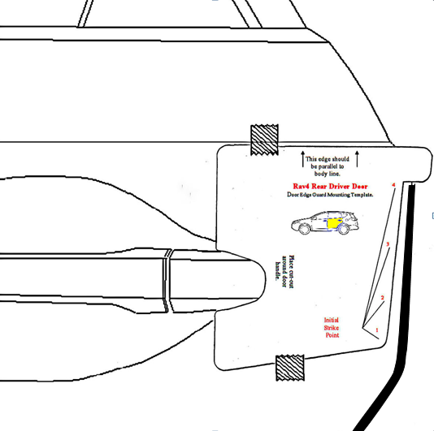

**NOTE:** The top of the DEG can be identified by matching the profile of the DEG to the door profile (Fig 1-4).

**NOTE:** In some instances, the free form shape of the DEG may differ from exact physical door contours. Production tooling consideration for the DEG provides the channel with ‘memory’ to conform to the exact door contours as the channel is installed.

caution_2

**NOTE:** BEFORE PROCEEDING IT IS EXTREMLY IMPORTANT TO PROPERLY ALIGN THE DOOR EDGE, DOOR EDGE GUARD CHANNEL AND MALLET AS SHOWN IN FIG. 1-5. MALLET TECHNIQUE IS VITAL FOR PROPER INSTALLATION

Fig. 1-5

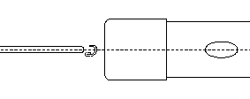

Outside of door

* + 1. caution_2Mallet blows need to be delivered squarely (broad face contact opposed to point contact) to the spine of the molding, and perpendicular to the door edge as shown. While holding DEG in proper alignment with one hand, use **soft side of the rubber mallet** to begin tapping the channel onto the door edge, starting at Striking Point #1 on the template (~3” inches below the top of the DEG). Ensure the channel is fully engaged onto the door edge before proceeding to the next step (Fig. 1-6).

Fig. 1-6

Rubber Mallet

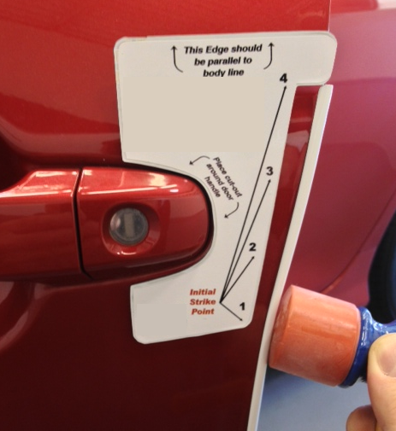



**NOTE:** If the DEG needs to be removed for any reason, it should be replaced with a new part. The DEG employs compression fit design for retention and appropriate retention cannot be assured if the DEG is reinstalled.

stop_2

**CAUTION: DO NOT PULL ON THE DEG; THIS CAN DAMAGE THE DEG AND THE FINISHED PAINT QUALITY.**

caution_2Follow the DEG removal procedure (if necessary) described in the NOTE below:

**NOTE:** Recommended removal technique is with use of a Nylon Removal Tool (NRT) (Fig. 1-7). Begin by positioning the tip of the NRT against the leading edge of the DEG on the outside face of the door. Gently tap the NRT just below the top of the DEG to begin disengaging the DEG, and tapping progressively down the length of the channel until about 3” from the bottom. Finish removal tapping from bottom of DEG working up, catching DEG as it comes off the door.

Nylon Removal Tool

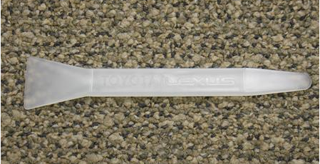

Fig. 1-7



* + 1. Continue tapping the channel onto the door edge moving toward the top of door before proceeding down the entire length of the DEG. Use your other hand to steady and guide the DEG as you go (Fig.1-8).

Fig. 1-8

Rubber Mallet

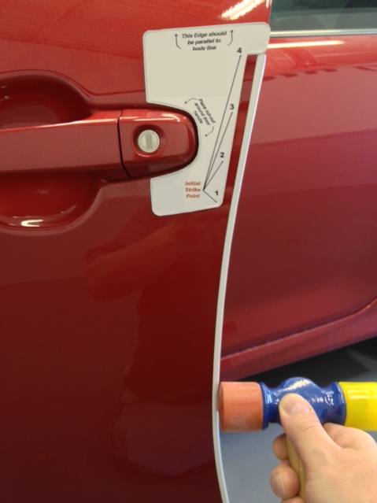



**NOTE:** IT IS IMPORTANT TO FULLY ENGAGE THE CHANNEL ONTO THE DOOR EDGE AT EACH POINT BEFORE YOU PROCEED DOWN AND AROUND THE CURVES OF THE DOOR

* + 1. With the DEG engaged along its full length, begin again at the top of the DEG, progressively tapping with moderate blows **(use the soft side of the mallet)** down the entire length to ensure the channel is fully seated.
    2. Carefully use the firmer side of mallet to **very lightly** tap down the length of the DEG. If it is fully seated, you should hear a solid report from the tapping.

**NOTE:** The intended purpose of this step is to listen for a solid report in response to light taps to confirm the DEG is fully seated. **THE FIRMER SIDE OF THE MALLET CAN DAMAGE THE DEG IF USED WITH MODERATE OR HEAVY BLOWS**. If the audible report received with a light tap indicates the DEG is not fully seated, repeat Steps 1(6) and 1(7).

* + 1. Carefully close the door and visually ensure the DEG has sufficient clearance from the adjoining body panels. Carefully remove the template from the door and retain for use on the passenger side (Fig. 1-9).

Fig. 1-9

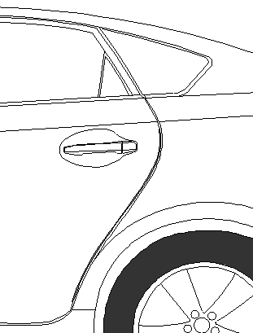

Front Door Edge Guard (DEG).

* 1. caution_2Prepare the surface(s).

**NOTE:** It is *critical* to this installation that the vehicle’s door edges are *completely free of wax and oil residue* to permit the DEG to engage and grip the door’s edge. The key goal for preparation is to ensure complete removal of residue that can prevent the DEG from gripping. Please follow the steps in their entirety.

* + 1. Fully open the front driver side door.
    2. Using 2 (two) lint free cloths:
       - 1. Spray three to four pumps of Simple Green (or VDC approved cleaner) onto a lint free towel and pinch the wet towel between your thumb and forefinger while running along the length of the door edge to clean the inside and outside of the trailing edge of door. Make several passes to ensure the wax and oil has been removed (Fig. 2-1).

Fig. 2-1

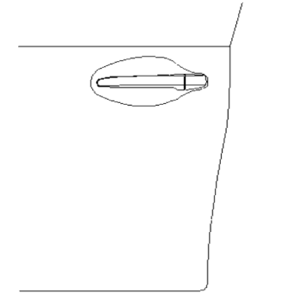

Trailing Edge

* + - * 1. caution_2Using the second lint free cloth, thoroughly dry the area free of Simple Green (or VDC approved cleaner) previously applied. In some instances a rubber weather seal may be found – ensure to clean between the trailing edge and rubber seal (Fig. 1-2). Turn the cloth repeatedly to attain a dry surface.

 

Fig. 2-2

**NOTE: To be cleaned correctly, resistance must be felt on the lint free towel and a “squeaky clean” sound must be heard during the drying process.**

* + 1. Repeat Step (2) if resistance is NOT felt and the “SQUEAKY CLEAN” sound is NOT heard. Keep repeating Step (2) until resistance is felt and a “squeaky clean” sound is heard.
  1. Install the Front Door Edge Guard (DEG).
     1. Select the front door template and fit the notch around the door handle. Adjust it as needed to ensure it is parallel to the body line directly above the template. If needed, tape it into place using painter’s masking tape (Fig 2-3).

Fig. 2-3

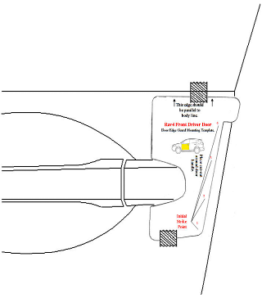

Align to Character Line



* + 1. Align the top edge of the DEG (labeled Front Driver with Pink sticker) with the lower edge of the template alignment notch as shown (Fig 2-4).

Fig. 2-4

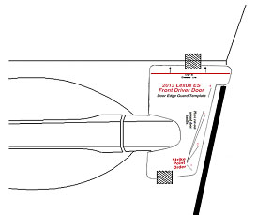

* + 1. caution_2While holding the DEG in proper alignment with one hand, use the **soft side of the rubber mallet** to begin tapping the channel onto the door edge starting at Striking Point #1, working your way to the top of the DEG (Fig 2-5). Ensure the top of the DEG is fully engaged on the door edge before proceeding to next step.

Fig. 2-5

Rubber Mallet





stop_2**NOTE:** If the DEG needs to be removed for any reason, it should be replaced with a new part. The DEG employs compression fit design for retention and appropriate retention cannot be assured if the DEG is reinstalled.

**CAUTION: DO NOT PULL ON THE DEG; THIS CAN DAMAGE THE DEG AND THE FINISHED PAINT QUALITY.**

caution_2Follow the DEG removal procedure (if necessary) described in the NOTE below:

**NOTE:** The recommended removal technique is with use of a Nylon Removal Tool (NRT) (Fig. 2-6). Begin by positioning the tip of the NRT against the leading edge of the DEG on the outside face of the door. Gently tap the NRT just below the top of the DEG to begin disengaging the DEG, and tapping progressively down the length of the channel until about 3” from the bottom. Finish removal tapping from bottom of DEG working up, catching DEG as it comes off the door.

Nylon Removal Tool



Fig. 2-6



* + 1. Continue progressively tapping the channel onto the door edge, proceeding down the entire length of the DEG. Use your other hand to steady and guide the DEG as you go (Fig. 2-7).

Fig. 2-7

Rubber Mallet





**NOTE:** IT IS IMPORTANT TO FULLY ENGAGE THE CHANNEL ONTO THE DOOR EDGE AT EACH POINT BEFORE YOU PROCEED DOWN AND AROUND THE CURVES OF THE DOOR

* + 1. With the DEG engaged along its full length, begin again at the top of the DEG, progressively tapping with moderate blows **(use the soft side of the mallet)** down the entire length to ensure the channel is fully seated.
    2. caution_2Carefully use the firmer side of mallet to **very** **lightly** tap down the length of the DEG. If it is fully seated, you should hear a solid report from the tapping.

**NOTE:** The intended purpose of this step is to listen for a solid report in response to light taps to confirm the DEG is fully seated. **THE FIRMER SIDE OF THE MALLET CAN DAMAGE THE DEG IF USED WITH MODERATE OR HEAVY BLOWS.** If the audible report received with a light tap indicates the DEG is not fully seated, repeat Steps 2(b)(5) and 2(b)(6).

Fig. 2-8

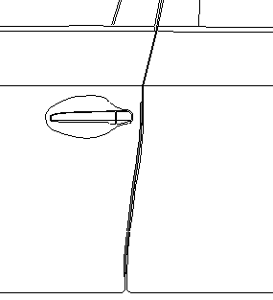

* + 1. Carefully close the front door and visually ensure the DEG has sufficient clearance from the adjoining body panels. Carefully remove the template from the door and retain for use on the passenger side (Fig. 2-8).

##### Repeat Steps 1 and 2 on the passenger side of the vehicle.

**THIS PAGE PPO ONLY**

caution_2

**NOTE:** The adjustment tool can be used if sealant is close to the door’s edge. This must be done to allow for proper **Door Edge Guard** installation (Fig. 3-1).

Fig. 3-1

Sealant Adjustment Tool HIG11-D5-01

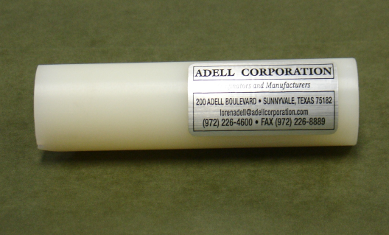

Align the adjustment tool to the edge of the door, with the angle edge positioned toward the inside of the door (Fig. 3-2).

Fig. 3-2

Depth gage (Side view)

Use the adjustment tool as a depth gage down the entire length of the door’s edge. This is to verify that the sealant material is back away from the edge of the door to allow for proper Door Edge Guard installation.

Align the adjustment tool to the edge of the door, with the angle edge positioned toward the inside of the door (Fig. 3-3).



Fig. 3-3

Angle tip in contact with sealant

With the adjustment tool angle tip in contact with the sealant material, push the adjustment tool inward so that the notched section of the tool is in complete contact with the door’s edge. Continue down the door’s edge or sections of the door’s edge that requires adjustment.

Accessory Function Checks

Confirm all Door Edge Guards are fully seated.

Vehicle Function Checks

Vehicle door operation.

Look for a fairly consistent gap between the DEG and adjoining vehicle panels.

**NOTE:** Normal vehicle manufacturing tolerances may exist that are not a consequence of an improperly seated DEG installation

Confirm all four vehicle doors open and close without interference from DEG or Body Side Molding (if installed).

Vehicle Appearance Check

After accessory installation and removal of protective cover(s), perform a visual inspection.

Ensure no damage (including scuffs and scratches) was caused during the installation process.

(For PPO installations, refer to TMS Accessory Quality Shipping Standard.)

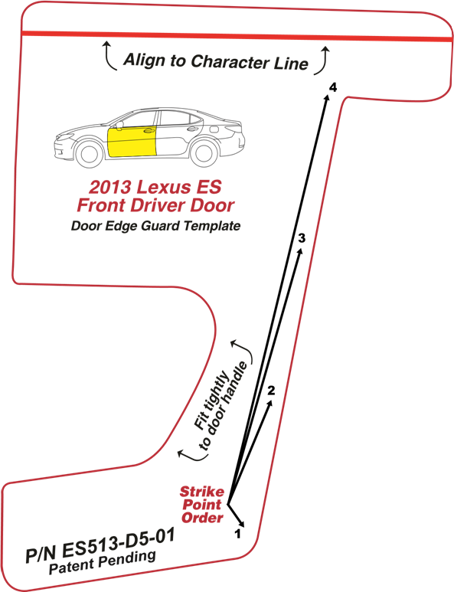

0”

1”

2”

3”

4”

5”

Dealer Installation Note: Check the above scale to ensure it is 1:1. Adjust on photocopier if it is not to scale. If this is a pdf document, set the “Page Scaling” to “None” in the Print dialogue box prior to printing.

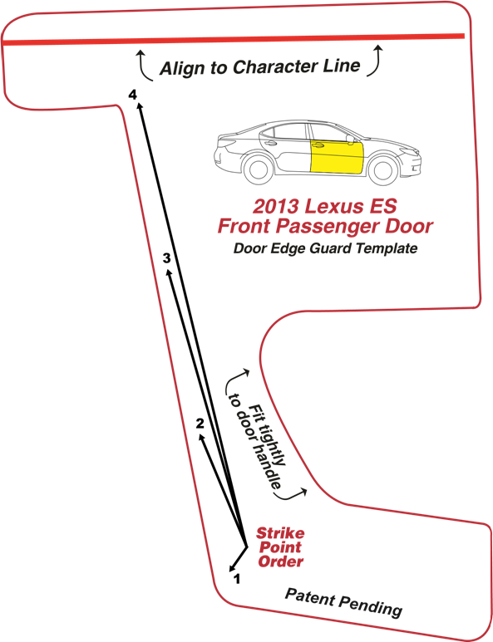

0”

1”

2”

3”

4”

5”

Dealer Installation Note: Check the above scale to ensure it is 1:1. Adjust on photocopier if it is not to scale. If this is a pdf document, set the “Page Scaling” to “None” in the Print dialogue box prior to printing.

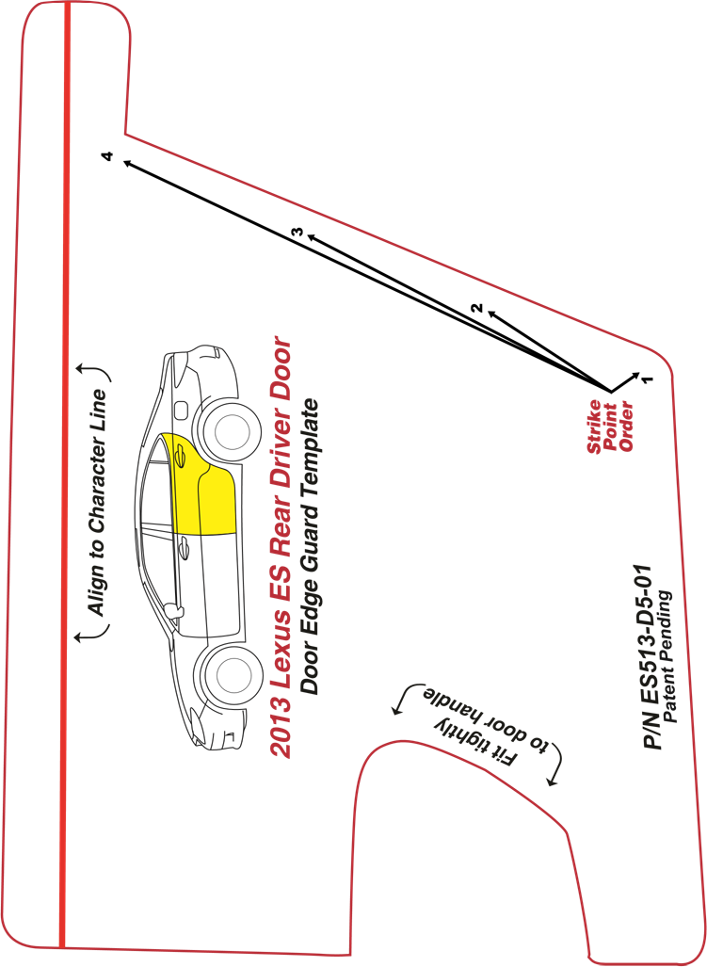

0”

1”

2”

3”

4”

5”

Dealer Installation Note: Check the above scale to ensure it is 1:1. Adjust on photocopier if it is not to scale. If this is a pdf document, set the “Page Scaling” to “None” in the Print dialogue box prior to printing.

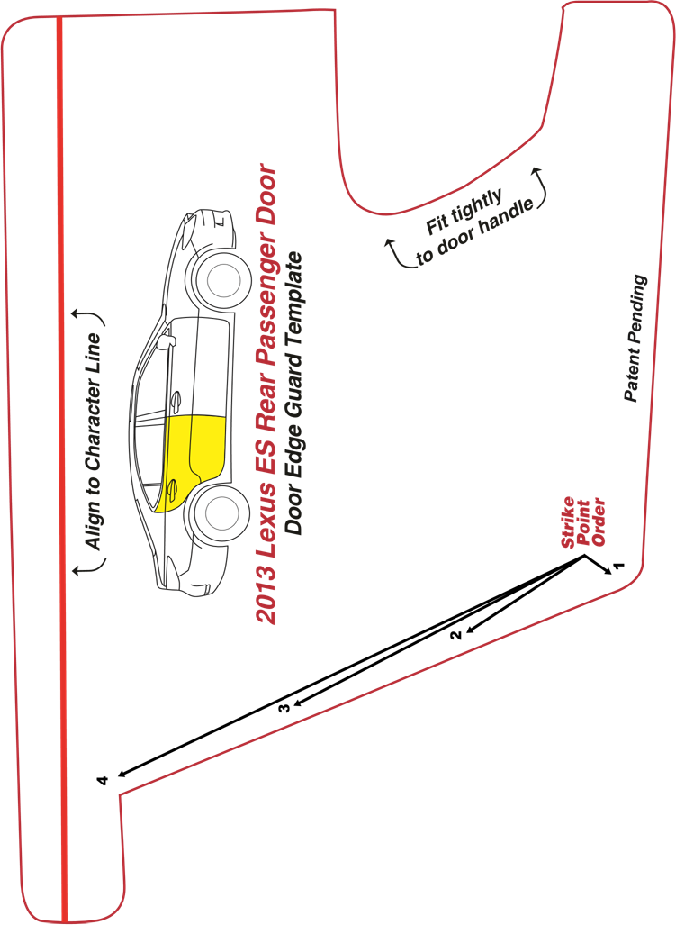

Dealer Installation Note: Check the above scale to ensure it is 1:1. Adjust on photocopier if it is not to scale. If this is a pdf document, set the “Page Scaling” to “None” in the Print dialogue box prior to printing.

0”

1”

2”

3”

4”

5”